**Inventory replenishment**

For both brothers or non-Brothers with non-inventory issues , Status = 33

1. Use TC - MWS420 (7, Blank) 🡪 Ref Order Cat: 3 (Customer order) 🡪 Enter MO
2. Highlight order line 🡪 related issues 🡪 Release for picking
3. Highlight order line 🡪 related issues 🡪 Picking List: Status changed to 40.
4. Highlight order line 🡪 related issues 🡪 Confirm Issues: Status changed to 90.

For both brothers or non-Brothers with inventory issue, Status = 22 (not allocated) or 23 (partially allocated)

1. PMS100 (2, 2) and change Facility 🡪 Enter MO Number



1. Highlight order line 🡪 related issues 🡪 Material & operations
2. Copy the Item number (Comp No), where the status = 22- reserved

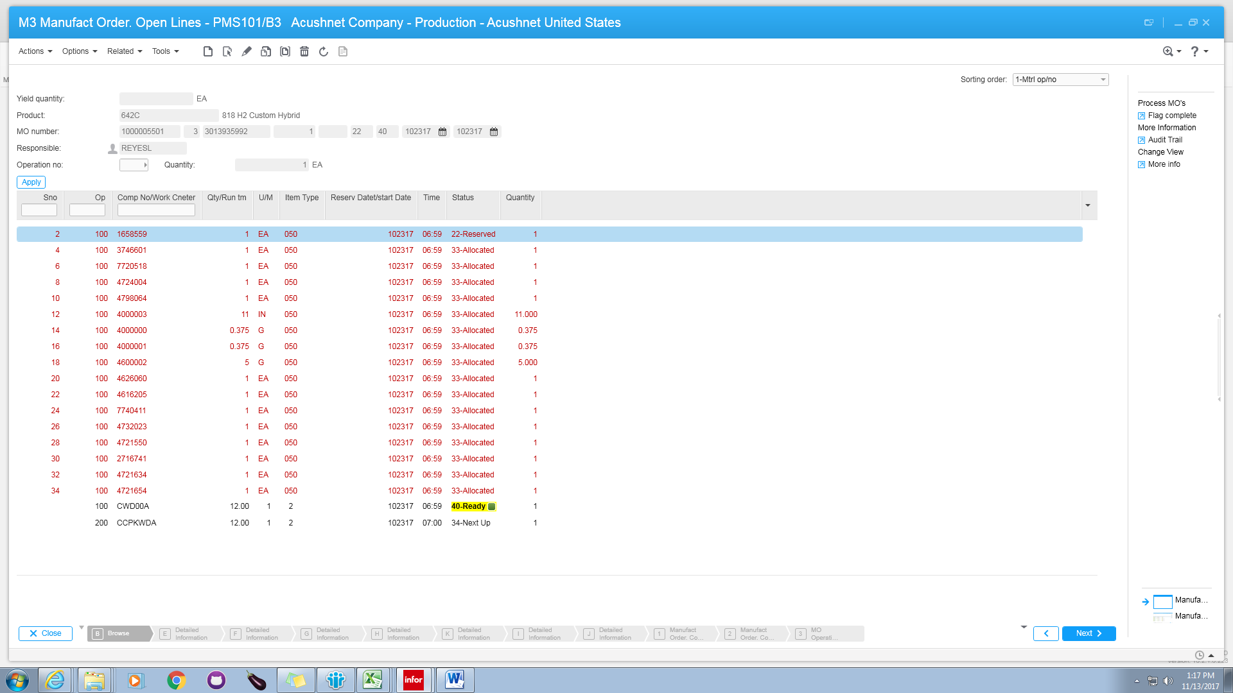

1. Open Transaction MWS060 (5, 5)🡪 enter the item number (Comp No: e.g. TB7SX1TA-0)
2. You can see that in location MPF09J1, there are 7 on hand but 15 are already allocated.
3. Check location with surplus and copy the number – in location MBK12C7, there are 60 available.

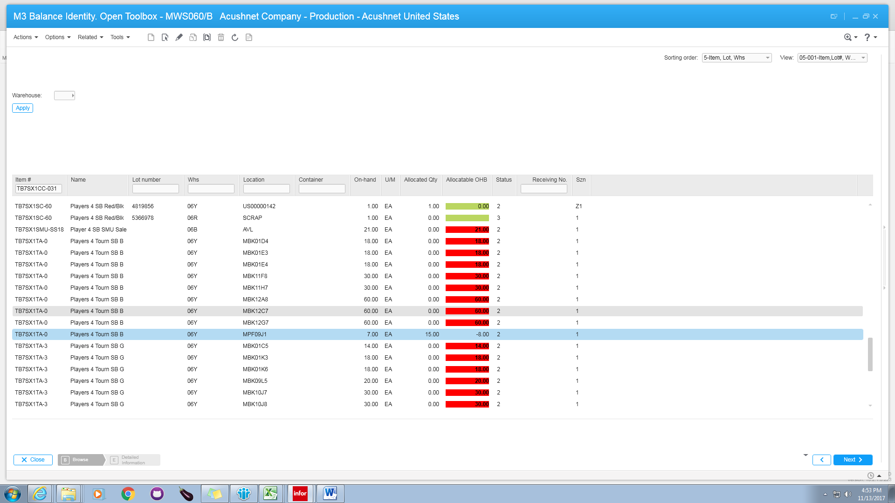

Use transaction - MMS175

Enter item number and To location 🡪 Next

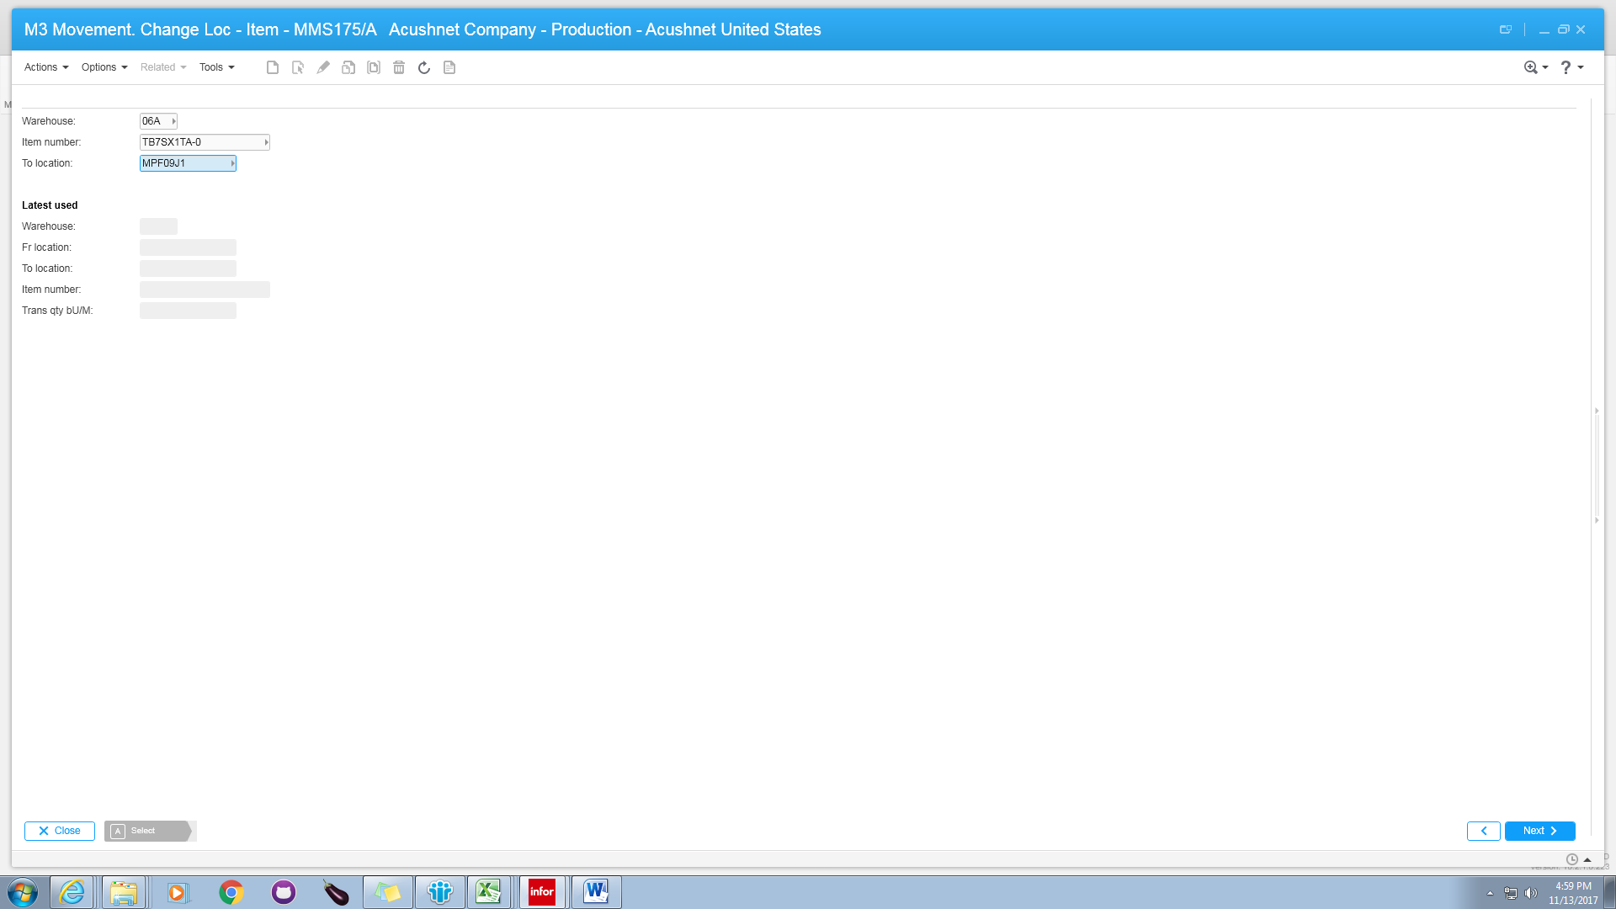

Enter the desire Trans qty bU/M: (I this case 60 are available)

Enter location 🡪 press Enter

Close Panel

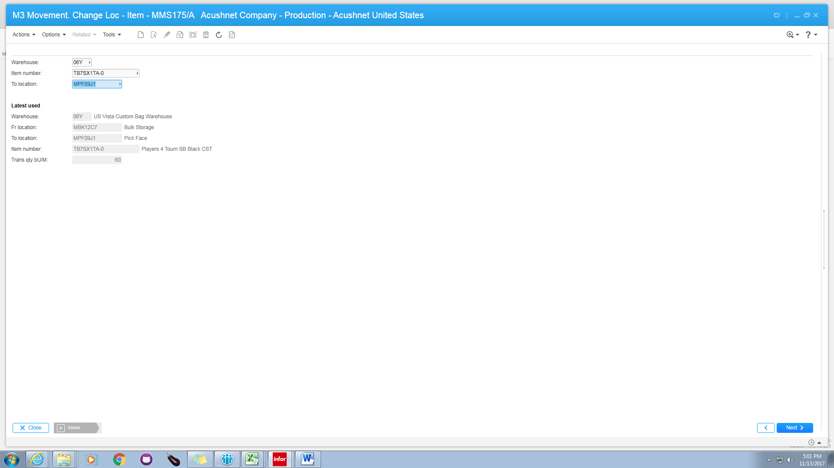

Go back to MMS060 and check that we have now 67 on hand

